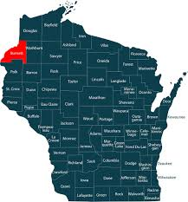

WIS 35: Lanquist Street to WIS 70 East
Burnett County
March 17, 2026

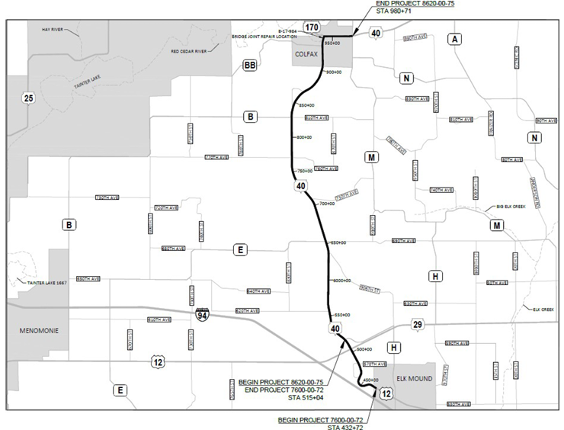

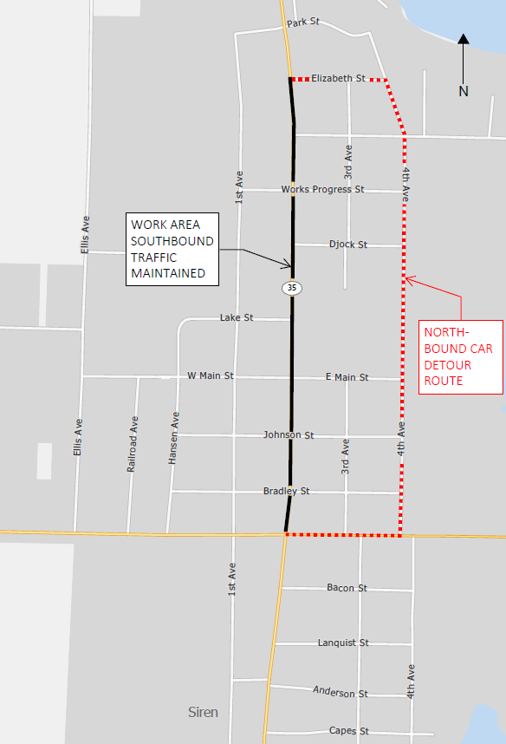
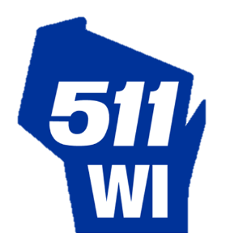
Construction
- Start: Currently anticipated to begin in mid-May
- Completion: Mid-October
Construction Website
- projects.511wi.gov/nwr5/
Project Contacts

Detour Information
  - Northbound car detour: County B, 4th Avenue North and Elizabeth Street.
  - Truck detour: WIS 70/MN 70, I-35 (MN), MN 48/WIS 77 and WIS 35.

Project Information
To address deteriorating pavement and other issues, the Wisconsin Department of Transportation project includes:
- Replacing pavement with new concrete from Lanquist Street to Southshore Drive
- Replacing storm sewer and expand its capacity from Lanquist to Works Progress Street
- Resurfacing the roadway from Southshore Drive to WIS 70 East
- Reviewing and revising access points
- Improving turning movements in all quadrants at the WIS 35 and WIS 70/County B intersection in the city of Siren
- Replacing traffic signals
- Replacing curb ramps
- Removing extra lanes from Park Street to Northshore Drive to reduce flooding potential
Traffic Impacts
During resurfacing from Southshore Drive to the WIS 70 East roundabout:
- Motorists will encounter single-lane closures controlled by flagging or temporary signals.
During the pavement replacement from Lanquist Street to Southshore Drive:
- Only southbound car traffic will be allowed, and northbound car and all truck traffic will be detoured.

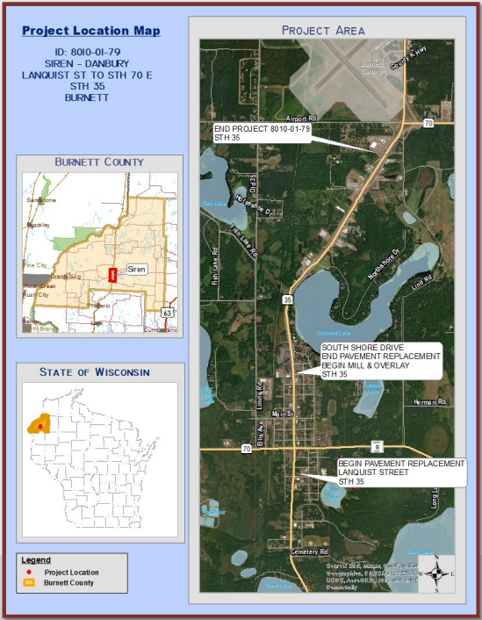

Constrution 2026


Cameron Shiffer
WisDOT Northwest Region
Consultant Project Manager
- (715) 495-2196
- cshiffer@correinc.com
Christena T. O’Brien
WisDOT Northwest Region Communications Manager
- (715) 828-9471
- christena.obrien@dot.wi.gov

Pat Lancour
WisDOT Northwest Region
Consultant Project Engineer
- (715) 558-2989
- plancour@nwbeinc.com

Tou Yang
WisDOT Northwest Region
Project Supervisor
- (715) 833-5570
- tou.yang@dot.wi.gov

Wisconsin Department of Transportation - Dedicated people creating transportation solutions through innovation and exceptional service.

